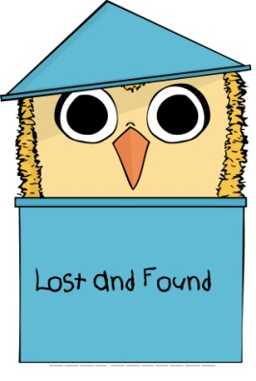

Character Creation
"Think left and think right and think low and think high. Oh, the thinks you can think up if only you try!" - Dr Seuss
Your character can be from any world, time, or place. Your Imagination is the limit. You will need to provide a back story and from this your future development skills will be defined and the thing you were looking for will be chosen.
When writing your back stories and character concepts please include :
- Your time period
- Your universe/world/planet/country (choose as appropriate)
- Your name (duh)
- your life in general ; relationships, careers, hobbies, whatever you feel is important
- Anything else you want to tell us.
The more you tell us the more we can understand who you are and want to be. But remember, when you arrive in Nowhere you will not remember who you are!
All characters begin their game with nowhere skills.
Nowhere Skills.
- Anyone can use a melee weapon and cause singular damage any additional weapons (guns/bows) are dependent of background and character.
- Any real life hard skills that do not require a weapon ; if you are naturally stealthy, good at hiding.
As your character develops and regains/finds their memory other skills will become available to you dependant on character background.
Special Skills
From your Back grounds and Concepts we will develop special skills tailored to the character. These will be chosen by the game team but if there is anything specific you feel would improve your enjoyment of the game or that your character just cannot live without please let us know and we will do our best to accommodate in as fairly as we can.
All Characters will have an Allowance of 5 Special Skills that they may "remember" throughout the event.
Props/Accessories/Special Weapons
These items can be anything that your character would of had on them in their day to day life; Guns, Electro Gloves, Doctors kits, Tool Box, Hand Grenades.......
These are things that are iconic to your character, for example :
- Robin Hood has a Bow and Arrow
- Harry Potter has a Magic Wand
- Richard Sharpe has a Rifle
- Thor has his hammer.
Items will be considered as a Special Skill and may come with use appropriate restrictions.
Send Backgrounds and Questions to: Lostandfoundlrp@gmail.com
or Alternatively
Please find a Character Creation Form Here:
https://docs.google.com/forms/d/1xzeaGdZMPsyOlZWbT6Vxibnuo_ad-Tc01SKYnKkeagY/viewform?usp=send_form

* * * * * * * * * * * *

